University of Florida
Department of Electrical Engineering
EEL 5666
Intelligent Machines Design Laboratory

Weekly Report 9
Summary

Over the past 2 weeks I have been swamped with research paper requirements. Therefore progress has been extremely limited. I anticipate that my research requirements will diminish substantially by sometime early next week.

A brief "obstacle avoidance" code was implemented which made the robot flap one way if one light sensor was covered and another if the other light sensor was covered. This code will be morphed so that it can utilize the inputs of the sonar. A 4GB SD card was obtained to give approximately 110 minutes of recording at a resolution of 720x480 pixels or 130 minutes at 640x480 pixels.

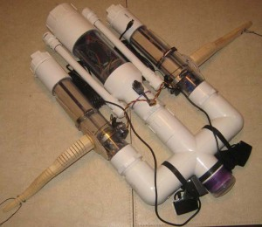
Figure 1: Current Status of Robot

Pitch control fabrication, getting the sonar working, and finalizing and building the wing will be the primary objectives in the upcoming week.

