University of Florida
Department of Electrical Engineering
EEL 5666
Intelligent Machines Design Laboratory

Weekly Report 4
Summary
An initial wing design was formulated this week and fabrication was started. Wooden alligators will form the flexible center spar. Two strings will pull the tail up and down with a servo mounted at the root chord. Airfoil-shaped high density foam tips will be glued on the front of each wood segment while the nylon swimsuit material will be sewn to hold everything together.

This week a major design decision was made. To facilitate diving and surfacing, it was decided to incorporate buoyancy modulation gliding. Flapping will still be the main source of thrust, but the buoyancy modulation will allow for more efficient movement and provide a backup means of actuation in case the flapping is ineffective. The modulation will be enabled by pushing battery packs forward and back of the center of gravity within each of the side tubes with a single servo and push rod.
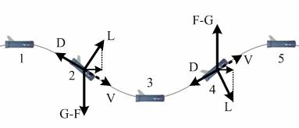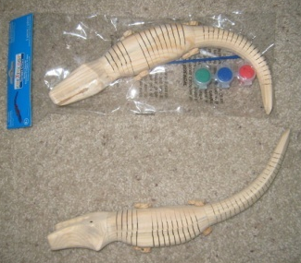
Figure 1. Buoyancy Modulation (http://www.naoe.eng.osaka-u.ac.jp/naoe/naoe7/MUG.html) and Wooden Alligators-the Keys to Quick Wing Design

The camera selection has been finalized and the camera was ordered. The camera system is a bullet camera with motion detection digital video recorder (DVR). For now the vision system with CMUcam with onboard vision processing will not be used since it is thought that technological progress will enable a better open source camera in the near future and the dimensions are too large. If there is sufficient time towards the end of the semester, onboard vision processing might be reconsidered.

A submersion test was performed. The board with a working program that included the LCD screen and 2 servos was demonstrated. Many necessary wiring connections were fabricated this week. The plan is to get LEDs and CdS cells working with the board on Thursday afternoon.

For next week, a sled that will provide mounts for the main electronics components will be designed and fabricated. The main power layout with batteries will be worked out. Lastly, board programming and sensor testing will be ramped up. This week a research paper submission on delayed progress.

