University of Florida
Department of Electrical Engineering
EEL 5666
Intelligent Machines Design Laboratory

Weekly Report 3

Summary
Fabrication of the main body started this week. The PVC chamber was finished, however the submersion test was delayed until next week to allow the PVC cement to dry. All parts except the camera and wing structural components were received this week, including the solar panel, CdS cells, LCD unit and two depth sonar units from Norcross Marine. Norcross Marine agreed to provide technical support and two new sonar units at the recertified price of $70 each. The camera selection has not been finalized although several alternatives to the CMUcam3 were identified this week.

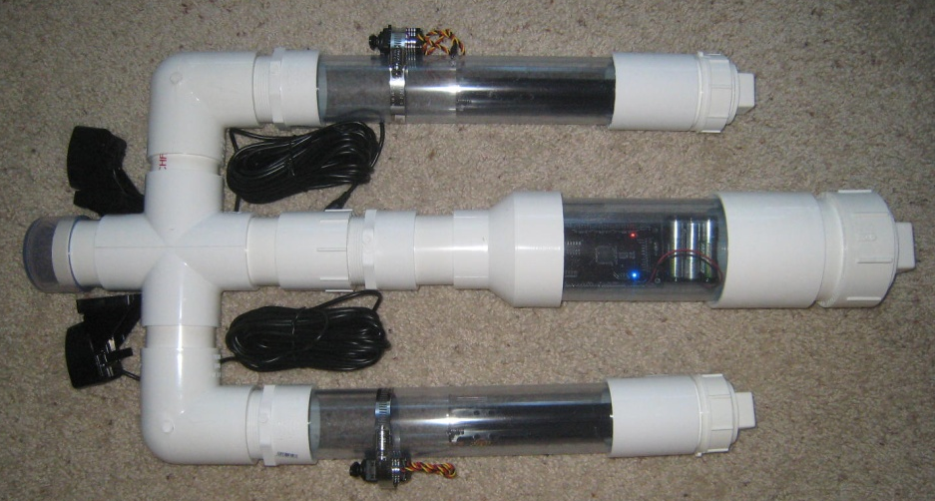
Figure 1. Approximate PVC body shape (before assembly)

Over the next week an initial wing design will be formulated and work will commence on sensor integration and initial programming for the CdS cells, LCD screen, LED, bump sensors and sonar units. The sonar will be tested soon to examine the feasibility of using two units and the effects of cross talk since both sonar operate at 20kHz. A sled also needs to be constructed to ensure quick access to the electronics in the main tube. Plans for final part locations, battery organization and wiring locations will also be addressed soon.

