University of Florida
Department of Electrical Engineering
EEL 5666
Intelligent Machines Design Laboratory

Weekly Report 2

Summary
Calculations were redone for the more accessible, single chamber, PVC body. Important issues including the initial wing design, power requirements and battery requirements were addressed. Servo and solar charger purchases were finalized although final sensor selections are still in progress. A lab journal has been started to record important concepts.

Structural Layout
Accessibility is a primary design consideration for the basic structure of the updated Solar Ray design. PVC tubes with screw in connections are utilized for the three primary tubes. The final design will consist of 6 main parts: 2 wings, 3 PVC tubes, 1 connection tube and 1 “jacket” made out of swimsuit material with a solar panel sewn into it. Wings will be connected to outside tubes with circular clamps.
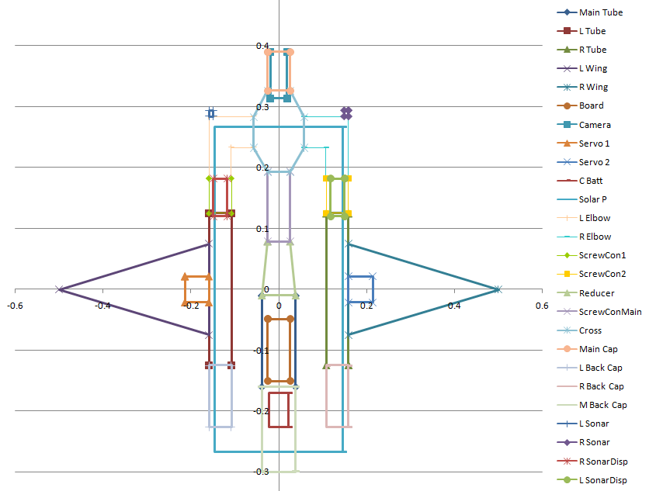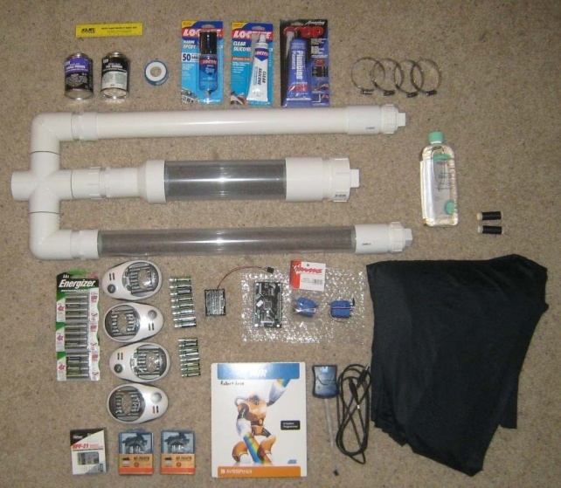
Figure 1. Layout Design and Parts (Without clear PVC cap, battery holders, voltage divider, solar panel, sonar, demonstrated with uncut PVC pipe)

Actuators and Sensors
Two servos with higher torque capabilities (486oz-in max) will be used to actuate the wings. However, these servos must be waterproofed first, unlike the 125 oz-in waterproof servos ordered previously. The higher torque should allow for larger heavier wings and substantially exceeds the amount of torque anticipated to be necessary. The waterproof servos with less torque may be used to form a type of tail later. All servos have been received. This week, Norcross marine was contacted to determine if they would sponsor the project by providing two D11S sonar depth finder units to mitigate the rapidly increasing price of the project. 2 CdS sensors, 2 bump sensors and possibly a camera will also be incorporated into the final design.

Finalized Calculations
The important calculations necessary to ensure a feasible design are shown below. Ensuring a positively boyant vehicle with enough actuation torque to flap at a kinematic profile known to produce thrust (around Strouhal number=0.3 or above) were primary considerations. Balancing the battery power and solar charger were also important. The charging will take longer than hoped, but for a prototype, the charging performance will be considered acceptable.
Anticipated Movement
Vmax=Max Forward Velocity | 0.5 | m/s
Vcruise=1/2 Max Forward Velocity | 0.25 | m/s
Kinematic Profile
Wing Beat Frequency (Max) | 0.5 | Hz
Wing Beat Period | 2 | s
Phase Lag (TE to LE) | 90 | degrees
Flapping Amplitude | 0.3 | m
Strouhal Number (A/Vt) | 0.3 | none

Boyancy Check
Air Displaced Main Cylinder | 0.0036939 | m^3
Air Displaced Dual Cylinder | 0.0032835 | m^3
Air Displaced Connections | 0.00139 | m^3
Max Air Displaced | 0.0069774 | m^3
Max Boyant Force | 6.9689612 | kg
% Electronics Main Cylinder | 0.3
% Electronics Dual Cylinders (est) | 0.1039135
% Electronics Dual Cylinders | 0.1
Real Air Displaced | 0.0069308 | m^3
Total Boyant Force | 6.9225015 | kg
Weight Check
PVC main tube & caps: est | 0.2 | kg
PVC dual side tubes & caps: est | 0.1666667 | kg
Basic Wing Structure | 0.5 | kg
Servos | 0.18 | kg
Pressure | 0.025 | kg
Camera | 0.198 | kg
Sonar: est | 0.85 | kg
Batteries | 1 | kg
Solar Charger | 0.29 | kg
Skin: est | 0.2 | kg
Structures: est | 0.35 | kg
Board | 0.05668 | kg
Random Wiring | 0.1 | kg
Total Weight of Robot | 4.1308467 | kg

Force/Torque Calculations
Min Drag Coeff (all frontal areas) | 0.3 | none
Estimated Drag Coeff (all frontal areas) | 0.5 | none
Max Drag Coeff (do something if this reached) | 0.8 | none
Frontal Drag Force (est) = Thrust Req | 18.479 | N
Frontal Drag Force (est) = Thrust Req Cruise | 4.620 | N
X Centroid of Wing | 0.273 | m
Y Centroid of Wing | 0.000 | m
Pivot X location | 0.159 | m
Avg Ang Velocity, Centroid of Wing, Max freq | 3.142 | rad/s
Avg Velocity, Centroid of Wing, Max freq | 0.357 | m/s
Total Drag Force on Wing as moves | 1.307 | N
Torque Possible/servo (=486 oz-in) | 0.350 | N*m
Torque Required/servo (=207 oz-in) | 0.149 | N*m

Power Check
Max Pwr Req (P=TreqVmax) | 9.2392917 | Watts
Cruise Pwr Req (P=TreqVcruise) | 1.1549115 | Watts
Power Req (Actuators Only) | 9.2392917 | Watts
Power Req (Electronics Only)-guess | 4 | Watts
Total Power Req | 13.239292 | Watts
Battery Calculations
Battery capacity (per 6 pack) | 15 | Ah
Charging Time | 50 | h
Total Battery Life (est) | 13.595893 | h

Main Purchase List (with sources and part numbers)
Note that the sonar and camera are the only things on this list that have not yet been purchased. Most items have been received, as shown in the figure on page 1.
Purchases | Amount | Supplier
2” and 3” PVC pipe, PVC cement, PVC connectors, silicone gel | 50 | Lowes
Dark Navy Nylon Swimwear, thread | 30.25 | www.fashionfabricsclub.com
PV Board | 128.1 | Prigin Vermeer Robotics
PV Board Programmer | 22 | Prigin Vermeer Robotics
2x3 Battery holders, snap leads | 28.03 | www.willyselectronics.com
Batteries 16 batteries, 4 chargers | 60 | www.techforless.com
Traxxas 2075 Digital High-Torque Waterproof Servos | 60.93 | https://www.rcsuperstore.com/
Threaded 2" PVC connectors | 16.97 | Lowes
1' 3" ID, 2' 2" ID Clear PVC tubing | 49.88 | www.aquaticecho.com
LM317 Voltage Down Converter | 6.99 | Asia Engineer, ebay.com
HS-7950TG High Torque Servo x2, Hitech HPP-21 Programmer | 266.97 | www.servocity.com
Clear 2" PVC cap | 25.02 | www.usplastic.com
LCD, CdS sensor x2, breadboard | 20 | www.sparkfun.com
2-3" #40 Circular Clamps x4 | 4.15 | Lowes
12 Energizer AA NiMh 2500mAh Batteries, Mineral Oil | 36.27 | WalMart
Hawkeye D11S Sonar Depthfinder x2 (est) | 160 | www.shopnorcrossmarine.com
CMU3 Camera | 250 | www.seattlerobotics.com
Powerfilm R15-30 300mA, 15.4V Solar Charger, cable, charge controller 12V, 4A | 135.5 | http://www.siliconsolar.com/flexible-solar-panel--powerfilm-5-watt-p-48.html
Total Spent | 1351.06

